TUGAS 04 CSS

Nama : Reyvaldo Arrizky Safaatulloh

Nim : 0110222213

Kampus : STT Terpadu Nurul Fikri

1. Form Pendaftaran  
   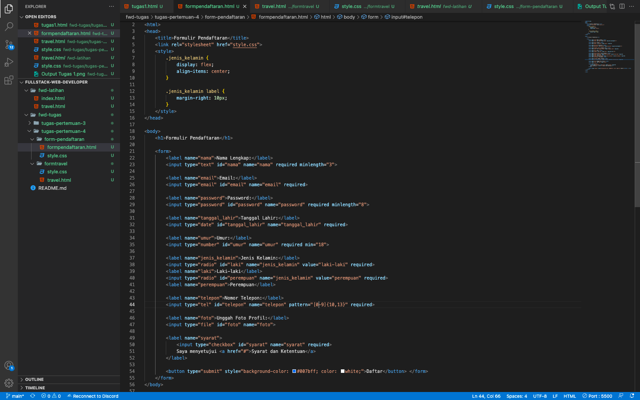

Style.css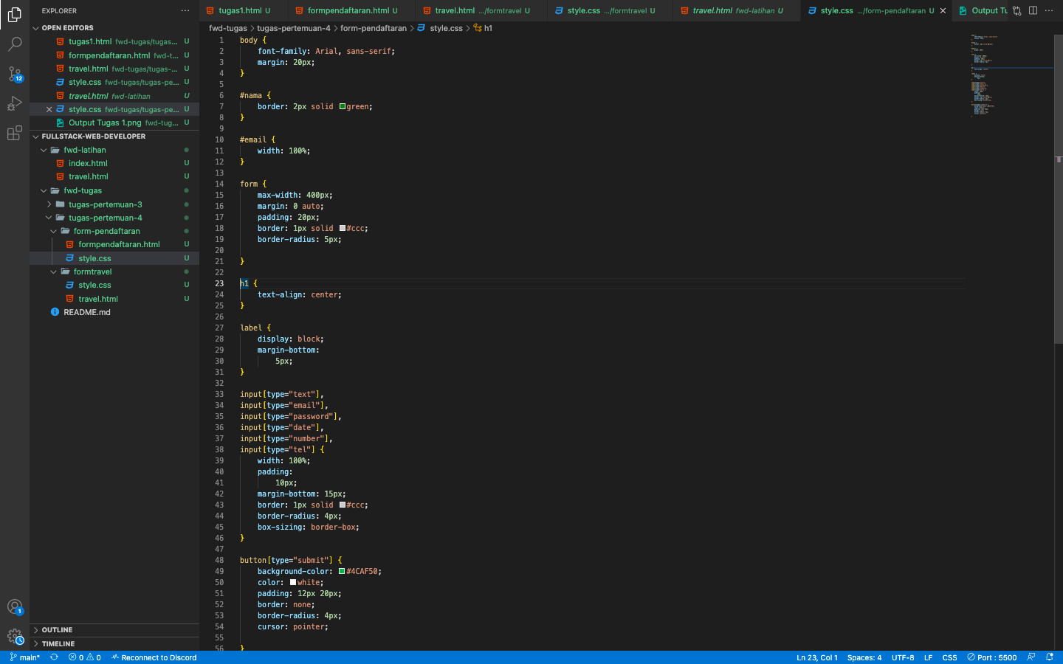

Output Form Pendaftaran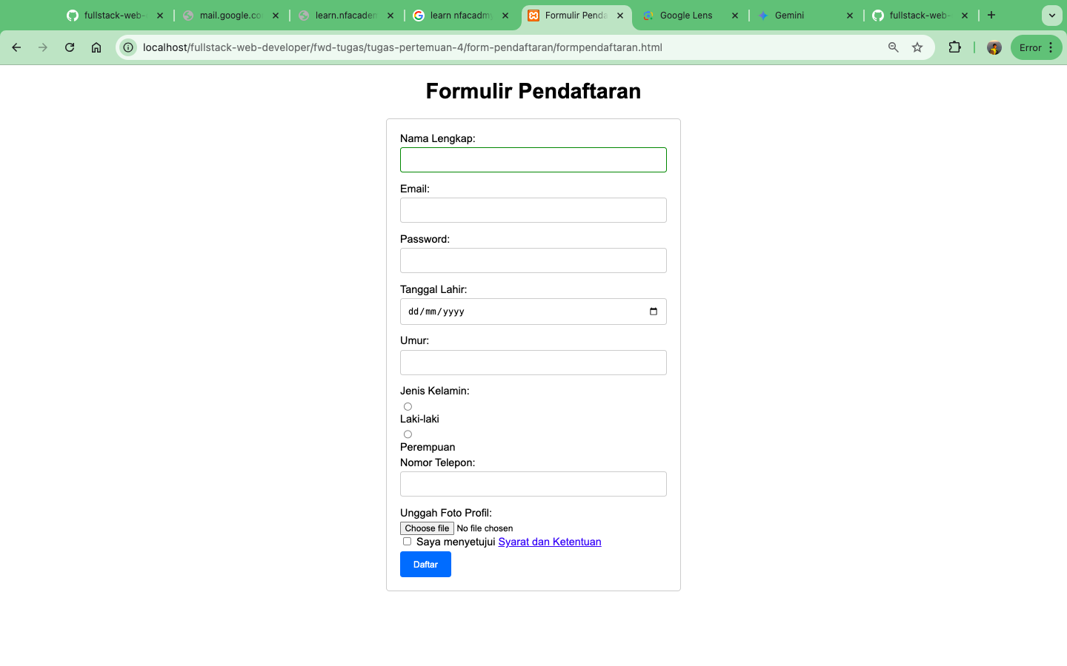

1. Form Travel

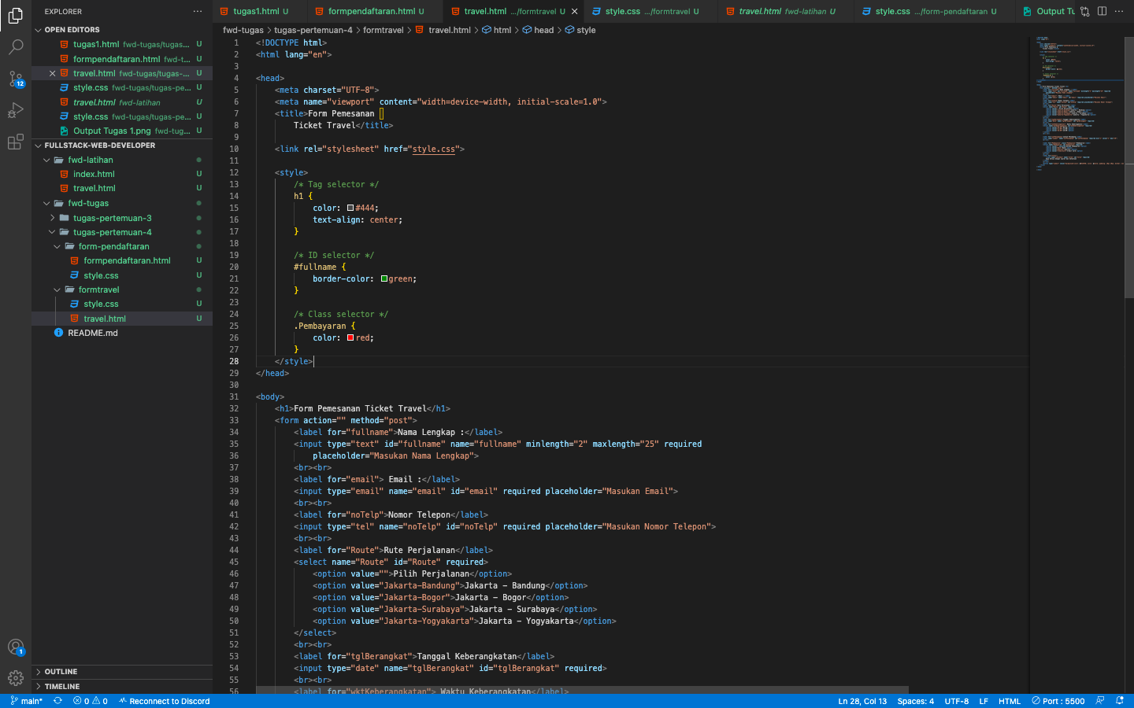

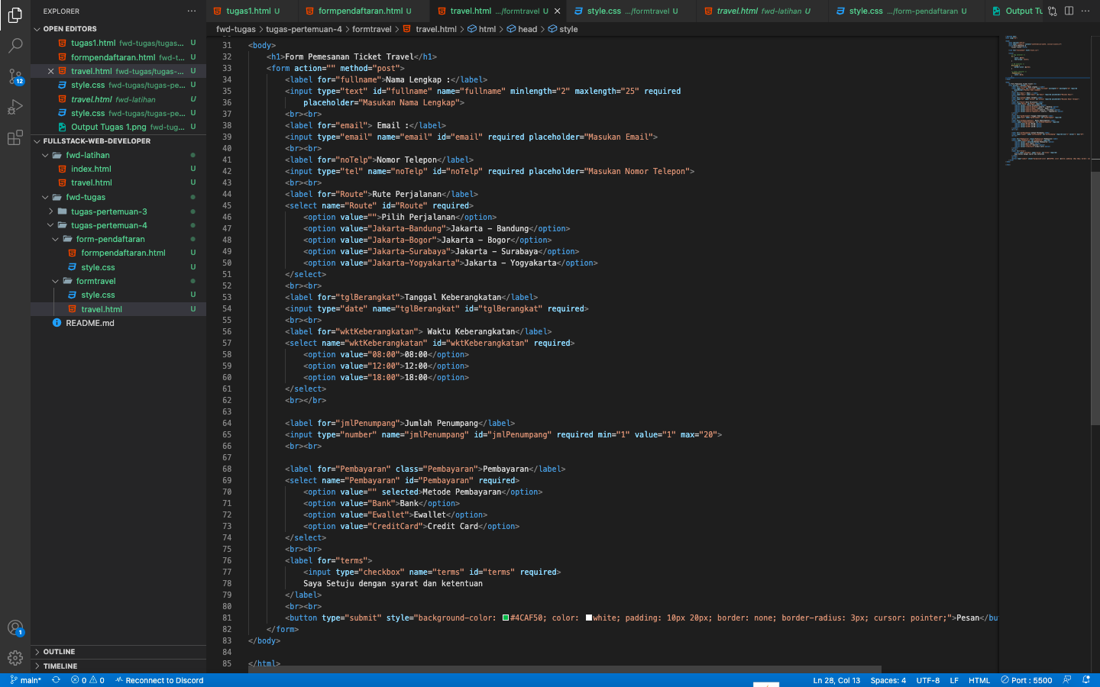

Style.css

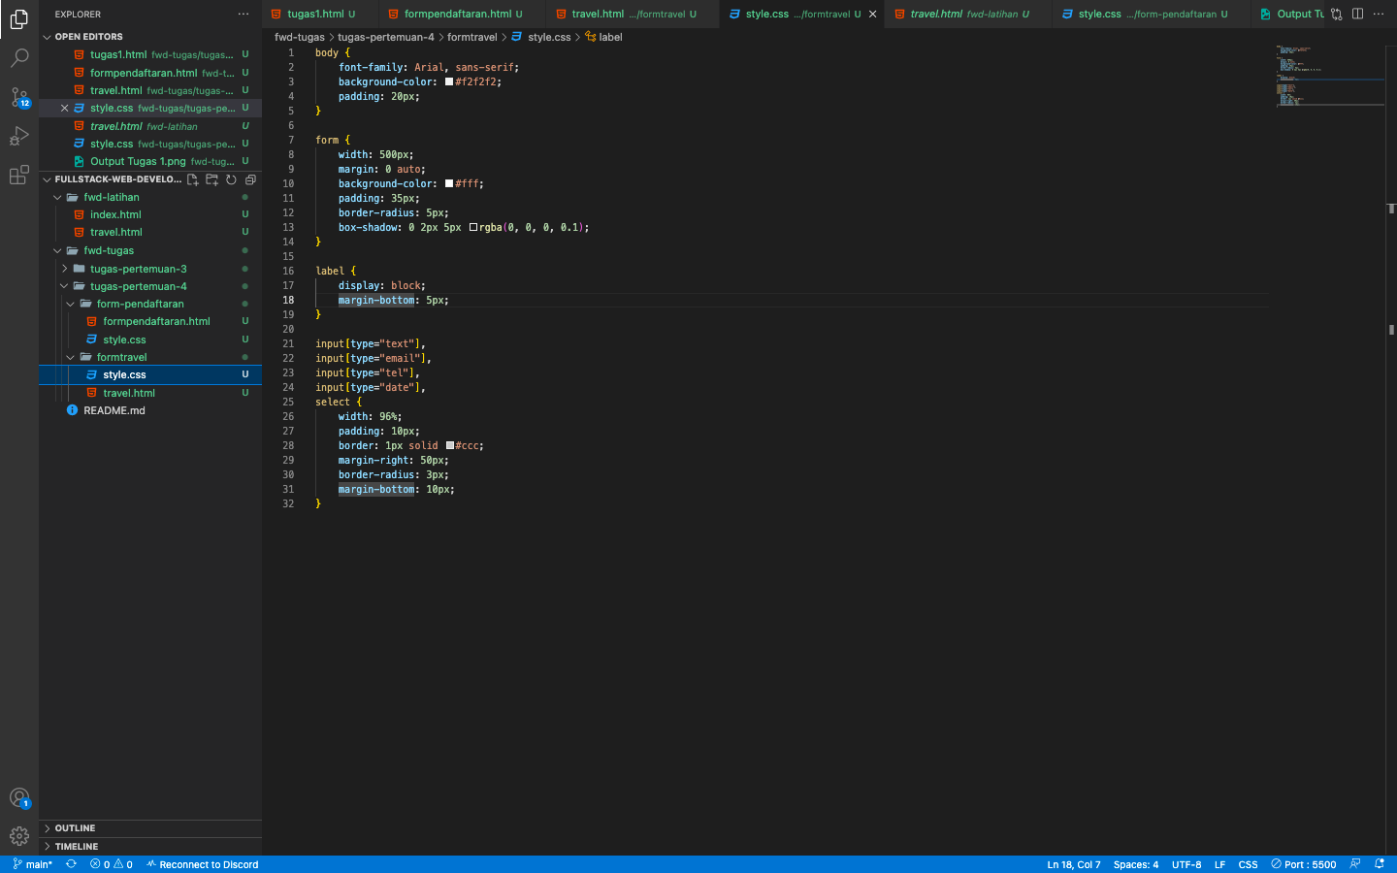

Output Form Travel

